## Y.Patil College of Engineering Akurdi.

*A*

*Project Report* On

Performing tests on Blood bank Management System using Selenium

SUBMITTED BY

NAME: Vikas Mane(B1921152) NAME: Abhijeet Bhalekar(B1921155)

CLASS: BE-B

GUIDED BY

Prof. P.B.Deshmukh



## COMPUTER ENGINEERING DEPARTMENT

Academic Year:2021-22

D.Y.Patil College of Engineering,Akurdi.



**CERTIFICATE**

This is to certify that **Mr. Vikas Mane(B1921152),Abhijeet Bhalekar(B1921155)**, a students of B.E. (Computer Engineering Department)

## Batch 2021-2022, has satisfactorily completed a project report on “**Performing tests on Blood bank Management System using Selenium**” under the guidance of **Prof. P.B.Deshmukh**.towards the partial fulfillment of the fourth year Computer Engineering Semester I of Pune University.

Prof. P.B.Deshmukh Dr. D.A.Potey Project Guide Head of Department

# CONTENTS

1. Problem Statement and Objectives
2. Introduction
3. Methodology
4. Result
5. References
6. **PROBLEM STATEMENT**

Check the functionality of Blood Bank Management System website using Selenium web-automation tool.

# INTRODUCTION

* The testing of a software product is one of the significant phases of Software Development Life cycle (SDLC). The testing process aims at finding the faults in the source code which might lead to bugs in the functionality of the software. Testing increases the quality of the software. A log containing all the details of the results obtained in the testing process is maintained.
* Selenium Web Driver is a programming interface to create and run test cases. It provides a way to act on various web elements.
* Why should I use Selenium ??

1. Open-source
2. Large support from the community and the user base is huge
3. Cross-browser compatibility (Firefox, Chrome, Edge etc.,)
4. Multiple programming language support (Python, Java, Perl etc.,)
5. Distributed Testing is also supported.

# METHODOLOGY

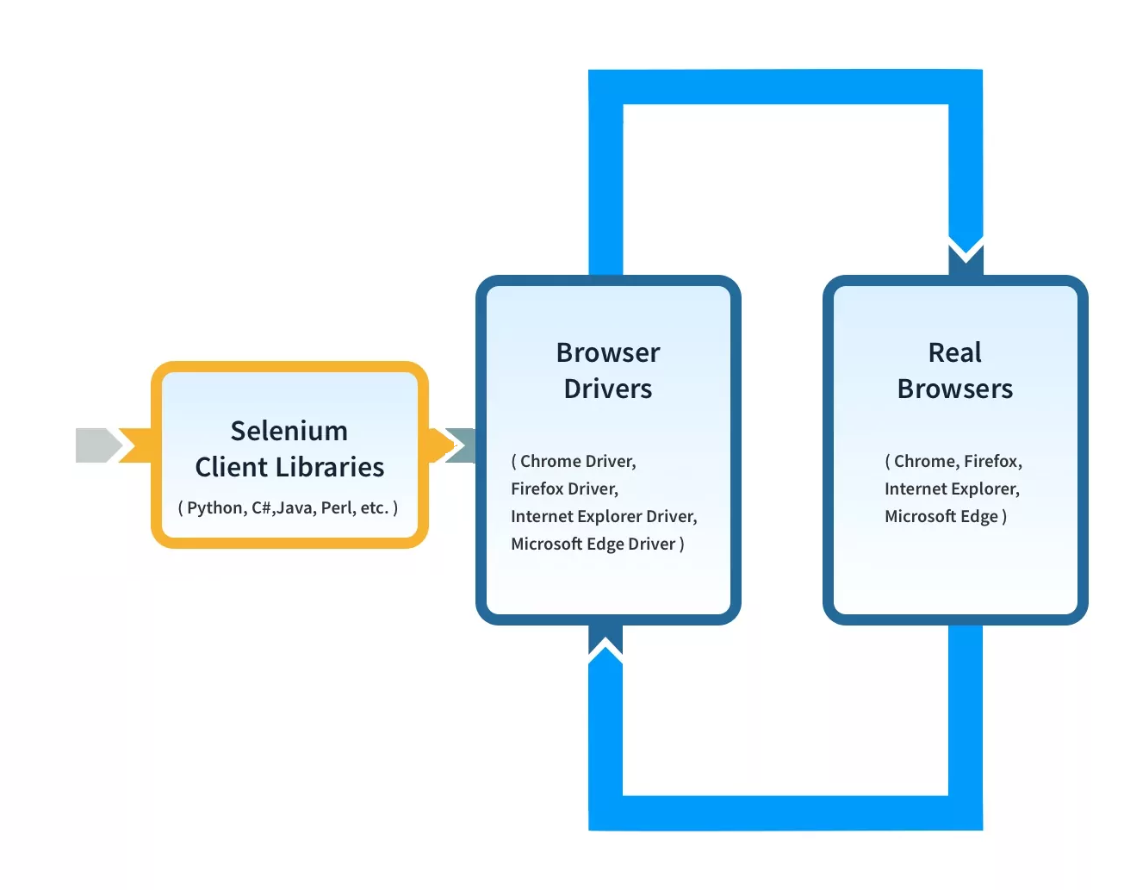

1. **TEST REPORT**

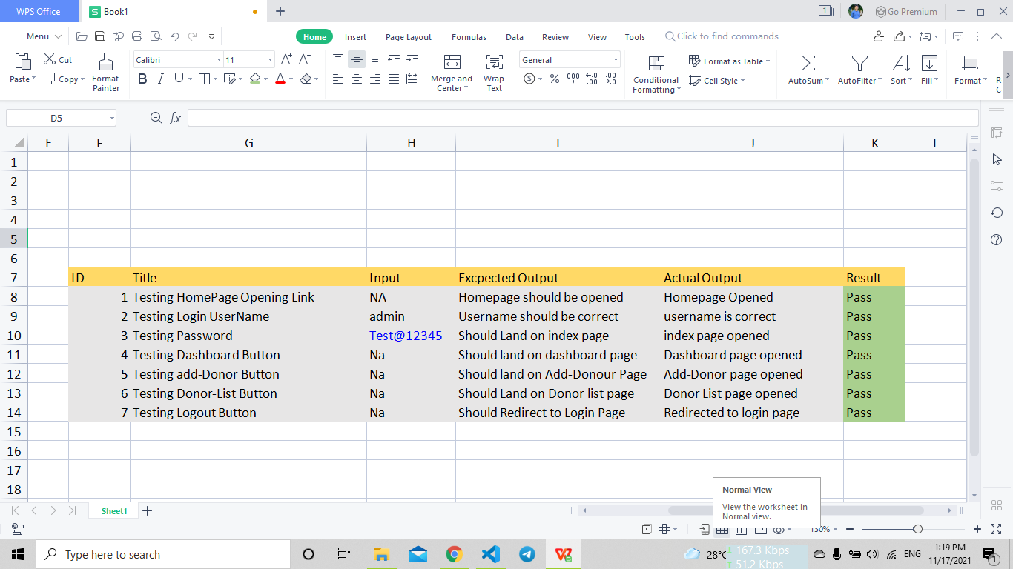

# 6.REFERENCES

1. FitNesse (Web Site: http://www.fitnesse.org)
2. Selenium, (Web Site: http://www.openqa.org/selenium)
3. Selenium Frequently Asked Questions, (Web Site: http://wiki.openqa.org/display/SEL/FAQ)
4. Testing using Selenium Web Driver Paruchuri Ramya, Asst Professor , P Vidya Sagar, Asso. Professor Dept.of Information Technology VR Siddhartha Engineering College Vijayawada, India, 2015
5. http://www.codeproject.com/Tips/351122/What-issoftware-testing-What-are-the-different-types
6. http://www.softwaretestinghelp.com/types-ofsoftware-testing/